Sort and filter

Sort: Arrange the Records in Ascending or descending order

## Normal Data: Before Sorting

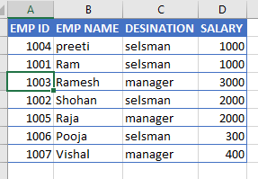

Select the Table->Home->Sort and Filter from Editing Ribbon

Select the Column -> Choose Ascending (A to Z) or Lower to higher

## After Sorting

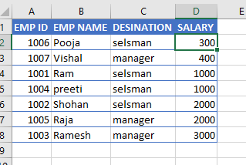

**Note: Smallest to largest based on Salary Column**

# Filter: Filter the Record similar type

Filter display the specific type of the Record just like Display the only salesman Record

Select Table-. Home-> Format as Table-> choose Design

Pick the Designation column -> Uncheck the Select All -> And Select the Salesman Option

# Operation on the Data:

Salary Calculation: Find the Gross Salary and Net Salary According to the Allowance

Given Allowance:

|  |  |  |
| --- | --- | --- |
| **Allowance** | **Rate %** |  |
| DA | 10 | Dearness Allowance |
| TA | 5 | Travel Allowance |
| HRA | 15 | Home Rent Allowance |
| PF | 8 | Provident fund |
| IT | 6 | Income Tax |
| GS |  | Gross Salary |
| NS |  | Net Salary |

# Show Formula

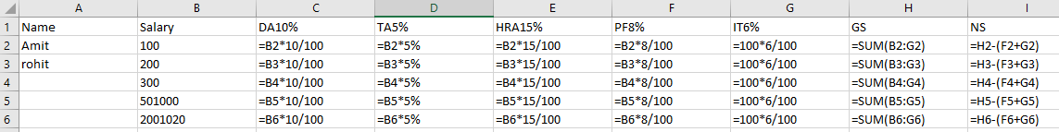

# Calculated Value

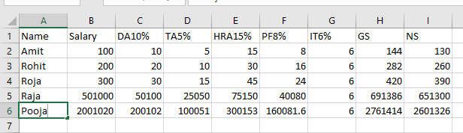

## Direct Value and Address Value:

Above Given Formula Column G Have Direct Value Assigned so It’s Calculation is Constant (Fixed value)

But in other case such as Column A, Column B …. Used the Address value So It change according to the Salary Column

Because address value is also relative Address it change according to the row

Absolute Address require to fixed the value:

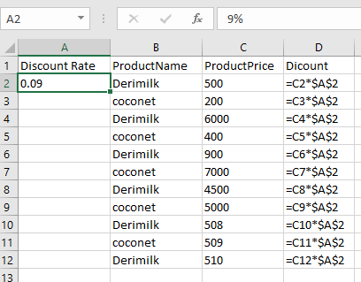

Convert Relative address into Absolute Address

Before Convert

A2

After Convert

$A$2

Calculate Value / Formula Value:

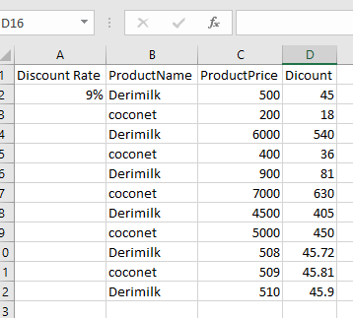

Profit Loss

# Practice Sheet

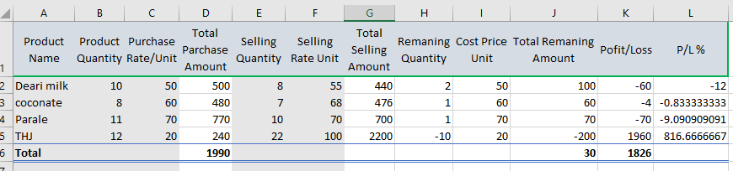

# Formula

